COMP .6212 DATAMANAGEMENT

(18/06/19)

By: Brad Fox

ID: 10000703

Paper: COMP.6212

Assignment One

1. Current Car Parking System 3

2. Automated Car Parking System(s) 3

3. Object-Oriented vs Traditional Software Development 3

I. Traditional Software Development 3

II. Object-Oriented Development 3

III. Preferred approach: Object-Oriented Software Development 3

4. Object-Oriented Software Development Methodologies 3

I. Available Object-Oriented Methodologies 3

i. Methodology 1 3

ii. Methodology 2 3

iii. Methodology 3 3

iv. Methodology 4 3

II. Tools and Techniques for each Methodology 3

i. Methodology 1 3

ii. Methodology 2 3

iii. Methodology 3 3

iv. Methodology 4 4

III. Recommended Methodology 4

5. Problem Statement Matrix 5

6. Solution Candidate Matrix 6

7. Stakeholder Matrix 7

Glossary 8

References 9

## Report

The Clothing Traders have come with a problem that there database is not keeping up with their growth they have had in their business and are looking for a new up to date database. It will need to track profits and items.

This document is covering planning around a new database for Clothing Traders, goals set out what problems could rise. Will also have a page explaining the design/ERD of what the database is going to be able to achieve will also include business rules. This document will also cover success factors problem areas list of entities

## Plaining

#### Goals Critical Success Factors

Goals are to design a database that can handle more customers having the site running 24/7 and staffed needs to be able to track pricing of items to see if profits have been made or not.

Being within budgets

Staff being trained to use software

Software being user friendly

Project being on time or undertime meaning early

Project should be able to keep up with business usage

Being able to use cross platform ie… apple windows phones/ devices

Problems the data base is it can not keep up from demand can’t keep up with volume since the company’s growth also cant keep track of profits currently and if it can not keep up with demand it will cause more problems like loss of customers as orders not place then that will move into loss of income for the business and so on and so forth

#### List of entities

Customer

Customer entity is customer first name last name phone number for ether daytime and night time address id for set customers.

Sales Rep

Sales Rep entity id first name last name phone number wages

Order

Order entity Date that order is places order number payment method (email phone website) Sales rep id /order placed

Item

Item entity Items order items sold type of item description categories of items size colors

Item-order

Sub entity covering items that have been ordered but not available and have been put on back order. Different supplies for items may accrue.

Supplier

Supplier name address phone number

Shipment

Cargos date of arrival and items and quantity shipment number

## Business matrix

|  |  |  |  |  |  |  |  |
| --- | --- | --- | --- | --- | --- | --- | --- |
|  | Customer | Sales Rep | Order | Items | Item – order | Supplier | Shipment |
| List of Customer’s and their orders | x | x | x |  |  |  |  |
| The items sold on a particular order from a customer |  | x | x | x |  |  |  |
| List items in a shipment with the arrival date |  |  |  |  | x | x | x |

## ERD

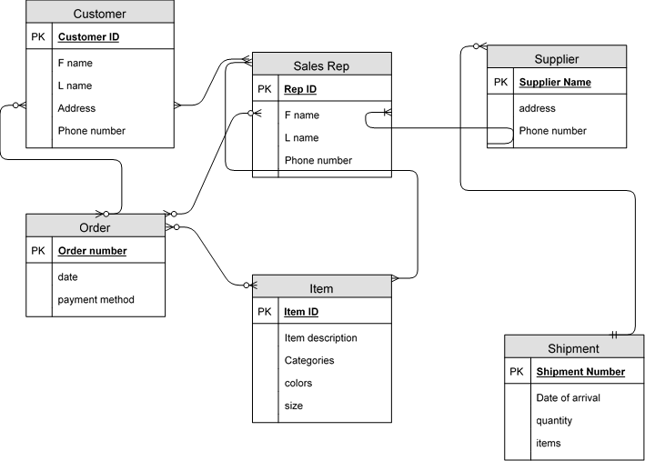

## Business rules

A customer may submit any number of orders, each order can be submitted by only one customer. The customer must be potential inactive, or some other customer possibly without any related orders

The order must request at least one item/product a product may not be requested on any order or may be requested on many orders or one order

A supplier may supply many items. Each item’s is supplied by any number of supplier’s

A shipment must include at least 1 item an item maybe included in many shipments